OFFICE REVAMP PROJECT Q2, 2022

SINCRO SITEWATCH LTD

Contents
1. PROJECT DESCRIPTION 3
1.1 PROJECT JUSTIFICATION 3
1.2 PROJECT CHECKLIST 3
1.3 PROJECT KEY MEMBERS 3
1.4 PROJECT DELIVERABLES/ MILESTONES 4
1.5 PROJECT REQUIREMENTS 4
PROJECT WORK BREAKDOWN SCHEDULE (WBS) 5
PROJECT IMPLEMENTATION PLAN 6

PROJECT DESCRIPTION

1.1 PROJECT JUSTIFICATION
This project is to revamp the general look of SSW HQ. This aims to improve the working environment as part of enhancing performance of the team. Most employees spend at least 8 hours in the same environment hence their surroundings occasionally needs to be improved. Furthermore to comply to the requirement of OHS Act of 2003 section 43 which requires an employer to ensure safe means of access and a safe working place. Also, Section 95 (1) (2) General duties of employers/occupiers require ensuring health safety and welfare at work of all employees.

1.2 PROJECT CHECKLIST
 | TASKS | STATUS | Remarks
1 | Gathering information through stakeholder meetings | ☒ | This was done at the Morning meeting and through the committee meeting 19-20 May2022
2 | Identifying Key team members | ☒ | The committee comprises of 5 members as of now
3 | Create a Work breakdown schedule (WBS) | ☒ | This was implemented during the meeting on 20TH May 2022. Final Updates will be shared to the whole team and management
4 | Responsibility allocation and timelines | ☒ | 23-05-2022
5 | Create a Gantt Chart & Critical Path, project virtual(3D) Drawings/designs | ☒
6 | Project Costing/ Budget
7 | Upload the plan onto SAS | ☐
8 | Project Execution | ☐ | To start by 30 May 2022
9
10

1.3 PROJECT KEY MEMBERS
- ARCADO SHAYO – To ensure we meet quality standards as per OHS and ISO
- ADELICA BOKKO – In charge of the exterior improvement
- REDEMPTA CHIKOTI- Project Coordinator and in charge of the interior office appearance
- EMMANUEL MASHAURI – In charge of Engineering and Design
- LATIPHA TITUS- In charge of Engineering and designs
- NZARO KIMBUTE- Supervise all the Engineering works including the Workshop
- PASTORY HAMARO – Project Manager/Director

1.4 PROJECT DELIVERABLES/ MILESTONES
- Modified Interior and Exterior office environment
- Building finishing retouch i.e repainting the office, repainting fence walls in a color scheme that matches Sincro’s corporate branding. Masonry work (Civil repairs specifically the rooftop)
- Improved Garden and Parking lot
- Establishment of a rest place/ Dining/Kitchen
- Establishment of a conducive Workshop

1.5 PROJECT REQUIREMENTS
- Project Budget
- Project Resources/ materials and Human resource

PROJECT WORK BREAKDOWN SCHEDULE (WBS)

PROJECT IMPLEMENTATION PLAN

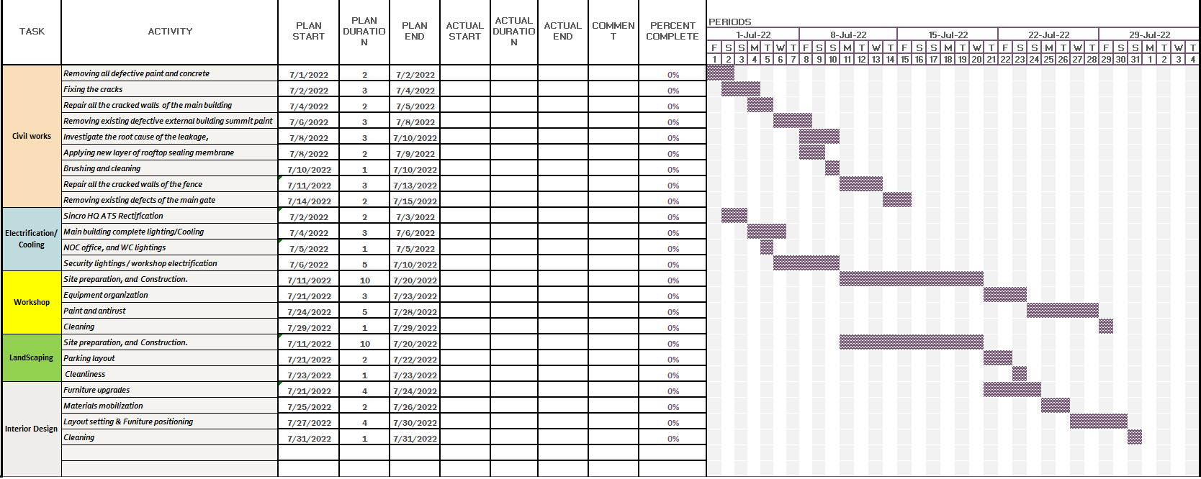

PROJE CT SCOPE OF WORK
This session will be used as a guidance in implementing the project including the project requirement
- CIVIL WORKS
Description | Actions Steps/Activities | Results | Duration
Step 1:  Directions: Main building | 1. Removing all defective paint and concrete | Identifying the crack root cause | 2 Days: (Saturday and Sunday
Step 1:  Directions: Main building | 2. Fixing the cracks | Plastering/skimming | 3 Days
Step 1:  Directions: Main building | 3. Repair all the cracked walls of the main building | Applying primer undercoat and upper coat of acrylic paint | 2 days
Step 2:  Direction: External works | 1. Removing existing defective external building summit paint | Applying a new layer of rooftop sealing membrane | 3 Days
Step 2:  Direction: External works | 2. Inspecting the cause of the leakage, | Applying a new layer of rooftop sealing membrane | 3 days
Step 2:  Direction: External works | 3. Applying a new layer of rooftop sealing membrane | Arresting the leakage | 2 Days
Step 3:  Direction: Wall fence Full painting | 1. Brushing and cleaning | Removing loose defective paint | 1 Day
 | 2. Repair all the cracked wall | Applying primer undercoat and upper coat of acrylic paint. | 3 days
 | 3. Removing existing defective main gate | Removing the rusted/corroded mild steel sheets and applying anti-rust paint. | 2 days

- HQ Workshop
S/NO | ITEM | DESCRIPTION | QTY | UNIT
1 | Flexible cable wire
2 | Flexible cable wire
3 | Construction materials | Cement, sand and gravel
4 | Industrial socket | Schneider Electric, PKY16F435, PratiKa IP44 Red Panel Mount 3P+N+E Right Angle Industrial Power Socket, Rated At 16A, 415 V | 2 | pc
5 | Bulbs | LED 60W | 5 | pc
6 | Socket | Double, Complete | 3 | pc
7 | Bench vice | Irwin Bench Vice x 100mm, Part No. 1978271 | 2 | pc
8 | Welding machine | ZX7-250 220V MINI Electric Welding Machine Household ARC MMA IGBT DC Inverter Welder Tool | 1 | pc
9 | Drilling machine | SIP 2620rpm Bench Pillar Drill, Part No. 01700 | 1 | pc
10 | Hydraulic Press | Facom 15t, Part No. W.415WBA | 1 | pc
11 | Grinding Machine | Makita GA4534 115mm Corded Angle Grinder, BS 4343 Plug | 1 | pc
12 | Datum table | Steel, 2000x1500x800 mm | 1 | pc
13 | Workbench | Wood, 3000x1000x800mm | 2 | pc
14 | Welding shields | 108 x 83mm Lens | 1 | pc
15 | Gloves | Honeywell Safety Black Leather Welding Gloves, Size 10, XL | 2 | pc
16 | Goggles | EN 166 | 2 | pc
17 | Wire brush | 10 inch, carbon steel welding brush | 2 | pc
18 | Chipping Hammer | Coil spring handle, 10.5in, with cone and vertical chisel | 1 | pc
19 | Mallet | Rubber Soft Faced Hammer 550g | 1 | pc
20 | Hammer | Single-handed hammer, D32X107X 330mm, Carbon Steel-head, Polypropylene (PP) / Carbon fiber-Handle | 1 | pc
21 | Tape measure | 8 meters/26 ft | 1 | pc
22 | Meter rule | Stainless, 1m | 1 | pc
23 | Jack Pallet | 3t Loading Capacity Hand Pallet Truck Manual Operated Pallet Jack | 1 | pc
24 | Fire Extinguisher |  | 2 | pc
25 | Trolley jacks | 442x206x135 mm, HS 8425421000 | 1 | pc
26 | Transmission jacks | Telescopic Transmission 55X37X88cm HS 84289090 | 1 | pc
27 | Jack stands | 1107A Pipe Stand V-Head | 4 | pc
28 | Mechanic pad | ‎41 x 18.5 x 4.75 inches, ‎6 Caster Creeper, model no ‎8505 | 1 | pc
29 | Air Compressor | 25.5 x 24 x 9.5 inches, GUT106-FBA-TR, 1HP | 1 | pc
30 | Torque wrenches | ‎ARM601 , complete | 1 | set
31 | Chain block | ‎TR9020, ‎10.63 x 7.87 x 6.3 inches | 1 | pc
32 | Vernier Caliper | UNSPSC Code 41110000, 6 to 7.9 Inches , 4 to 4.9 Inches, stainless-steel | 1 | pc
33 | Micrometer | UNSPSC Code 41110000, PH0086B, Nickel Plated Brass - Range 0-25x0.01mm | 1 | pc
34 | Ring spanner | COMPLETE | 1 | set
35 | Socket spanner | COMPLETE | 1 | set
36 | Box spanner | COMPLETE | 1 | set
37 | Combination spanner | COMPLETE | 1 | set
38 | Adjustable spanner | COMPLETE | 1 | set
39 | Allen key | COMPLETE | 2 | set
40 | Welding Apron | ‎‎ESAB 5.8 x 21 x 28.6 cm | 1 | pc
41 | Square Rule | Measuring scale: (Outside) 15 × 7.5 cm (Inside) 10 × 5 cm, Stainless steel (SUS430J2) | 1 | pc

- HQ LIGHT IMPROVEMENT
 | Installation materials
 | Security Light- (Complete LED Floodlight) | 50W- | Pc | 9
 | Holder for Men's Toilet | Pin Type | Pc | 3
 | LED Bulb for Men's Toilet | Pin Type-10W | Pc | 3
 | Holder for NOC office | Pin Type | Pc | 2
 | LED Bulb for NOC Office | Pin Type-10W | Pc | 4
 | Main Building Complete Light | 20W | Pc | 15
 | Mains Switch(Breaker)-EATON | 100A,Three Phase | Pc | 1
 | Breaker (ELCB)-EATON | 100A,Three Phase | Pc | 1
 | DP Switch | 15A | Pc | 2

- HQ Interior & Exterior proposal
Project aims to improve the appearance of the workspace and its surroundings. Thus creating a parking lot and a garden on one side as well as sorting and disposing some items. Below is a list of proposed items for disposal
- Metal fuel tanks | 2 units
- Old power generators. | 6 units
- AVR canopy | 1 unit
- Old motorcycle | 2 unit
- Old tyres | 5 pcs
- Office Board room Chairs

Furthermore, the interior office will include improving the boardroom by adding a display unit that is TV set which is currently at the old NOC office, Labelling of offices and improving the Emergency exits

